Tool Guide – Hashcat

1. Introduction & Purpose
Hashcat is a powerful password-cracking tool used in cybersecurity to recover passwords from their hashed forms. It supports a wide range of hash algorithms (MD5, SHA1, NTLM, etc.) and employs several attack modes such as dictionary, brute-force, and hybrid attacks.
Hashcat is widely used during the cracking phase of penetration testing, typically after hashes have been extracted during post-exploitation or enumeration.
Safety Disclaimer: Use Hashcat only on hashes and systems you are authorized to test. Cracking passwords without consent is unethical and potentially illegal.

2. Setup & Launch

Step 1: Open Deakin Detonator Toolkit
Launch Terminal in your Kali Linux (or compatible) environment and navigate to the Deakin Detonator Toolkit directory:
cd ~/Deakin-Detonator-Toolkit
Start the GUI interface:
yarn run tauri dev
This will open the main interface of the toolkit.

Step 2: Locate the Tool
- Click “Tools” in the left-hand menu or use the search bar.
- Scroll to Hashcat under the Cracking or Password Recovery category.
- Click the blue “Go” button to launch the tool.

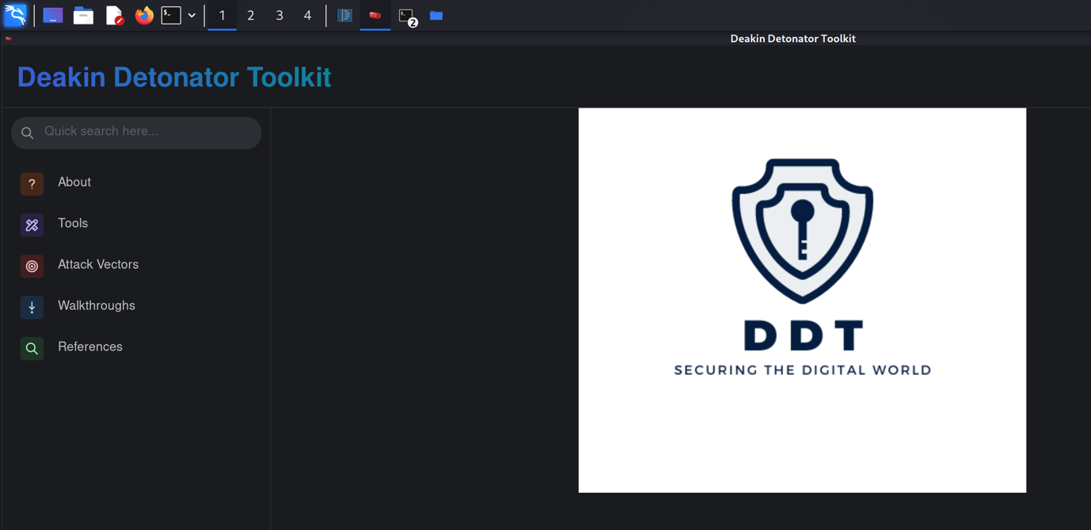

Step 3: Configure Hashcat
Once inside the Hashcat tool, you'll see several configuration options. These are flexible based on your cracking approach:
These settings are ideal for quick testing with a known hash and a popular wordlist.

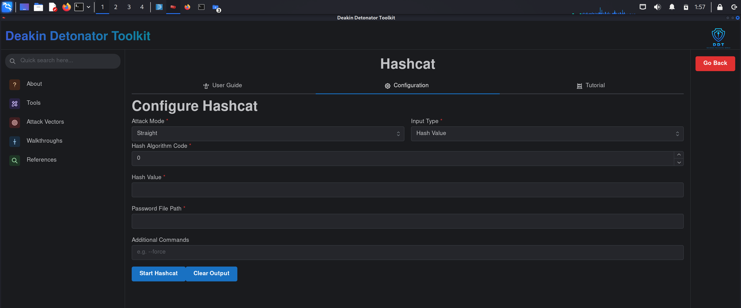

- Attack Mode: You can choose from:
  - Straight: Uses a wordlist (dictionary)
  - Brute-force: Tries all combinations
  - Hybrid Wordlist + Mask: Combines wordlist and pattern matching
For this guide, I chose Straight

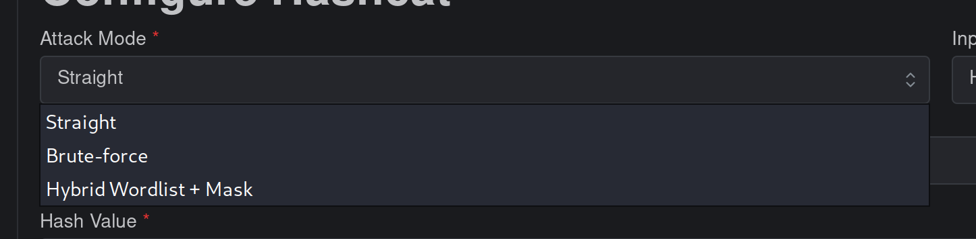

- Input Type: You can choose:
  - Hash Value: Enter a single hash directly
  - File: Use a file containing hashes
I selected Hash Value

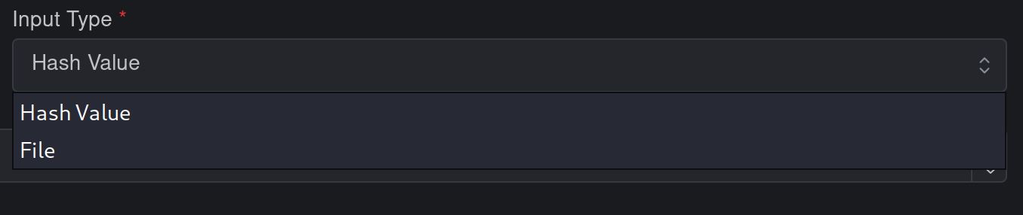

Step 4: Input Values
Now fill in the required fields to prepare Hashcat for execution:
- Hash Algorithm Code: I used 0, which represents the MD5 hashing algorithm. This tells Hashcat how to interpret the input hash.
- Hash Value: I used the hash 5f4dcc3b5aa765d61d8327deb882cf99, which is the MD5 hash for the password "password". You can use any hash you want to test, but make sure it matches the hash type you selected above.
- Password File Path: I used the popular wordlist rockyou.txt for this test. I had it saved in the Downloads folder, so I entered the path as:
/home/kali/Downloads/rockyou.txt
This file contains thousands of commonly used passwords and is ideal for dictionary attacks.
- Additional Commands (Optional): You can enter flags like --force to suppress warnings or -o output.txt to save results to a file. I left this field empty
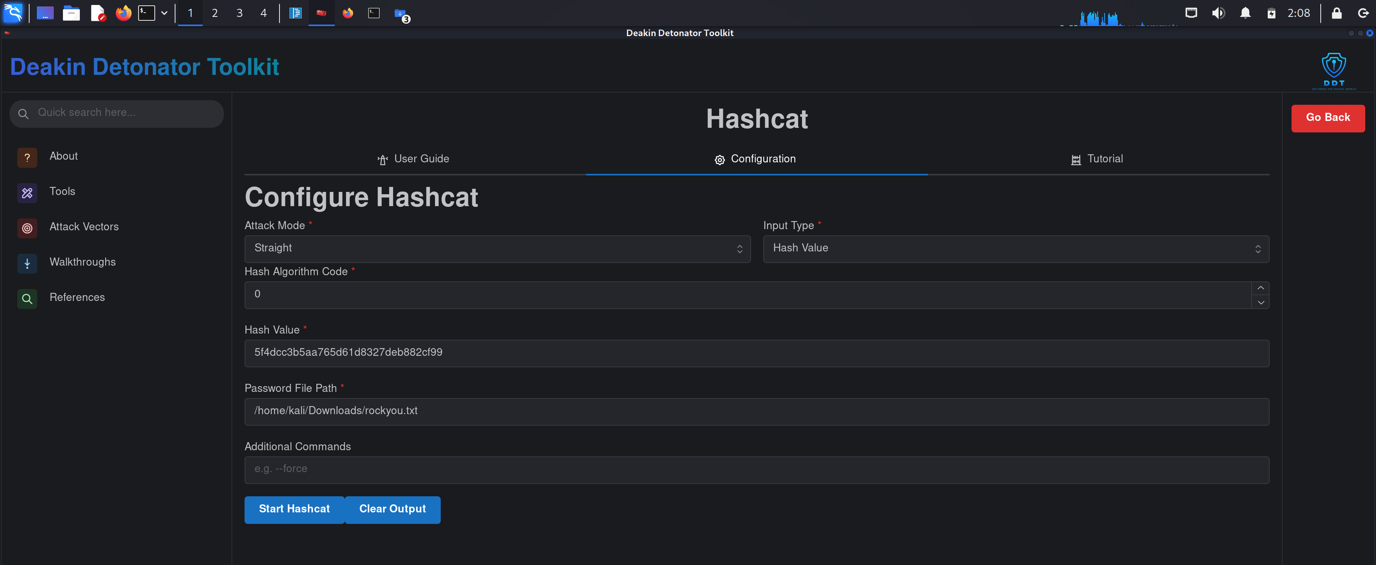

Step 5: Run Hashcat
Once all the fields are filled in, click the Start Hashcat button to begin the cracking process.
- Hashcat will start running, and you’ll see a short message indicating that it's initiating its attack.
- In this example, the process completed quickly, as the correct password (password) was found within the wordlist.

